Project Framework: Intelligent Partitioned Vector Search
This framework proposes shifting the burden of performance from hardware (buying more RAM) to software architecture (intelligent data structuring and query pre-processing).
Phase 1: Data Structuring (The Foundation)
Instead of treating legal documents as a "blob" of text, we enforce strict hierarchical metadata extraction during the data ingestion phase.
- Granular Segmentation: Every document chunk is tagged not just with text, but with rigid metadata: Act Name, Part Number, Section Number, and Legal Domain (e.g., Civil, Criminal, Corporate).
- Indexing Strategy: We utilize standard B-Tree indexes for the metadata columns to ensure $O(\log N)$ lookup speeds, while keeping vector embeddings storage separate but linked.
Phase 2: The "Smart Gatekeeper" Application Layer
Before any interaction with the database, the Python application layer sanitizes and optimizes the user input.
- Typo Correction & Normalization: Using lightweight string-matching algorithms, the system corrects user input against a "Silver Standard" dictionary of Malaysian legal terms (e.g., correcting "Indstrial Reltions" to "Industrial Relations Act").
- Intent Classification: The system analyzes the query to detect specific legal domains. If a user mentions "retrenchment," the system automatically tags the query scope to Employment Law, reducing the search field immediately.
Phase 3: The "Scoped Search" Retrieval Engine
This is the core innovation replacing generic HNSW indexing. We utilize a two-step "Filter-Then-Compute" execution model.
- Step A: Metadata Filtering (The Scope Down): The database executes a standard SQL filter first. It instantly discards irrelevant Acts (e.g., ignoring the Penal Code when the query is about Company Directors). This reduces the active dataset from millions of vectors to merely thousands.
- Step B: Exact Vector Calculation (The Precision Find): Because the filtered dataset is small, we bypass approximate indexes (HNSW) and run an Exact Nearest Neighbor search. This guarantees 100% mathematical accuracy for retrieval within the filtered scope, with negligible latency.
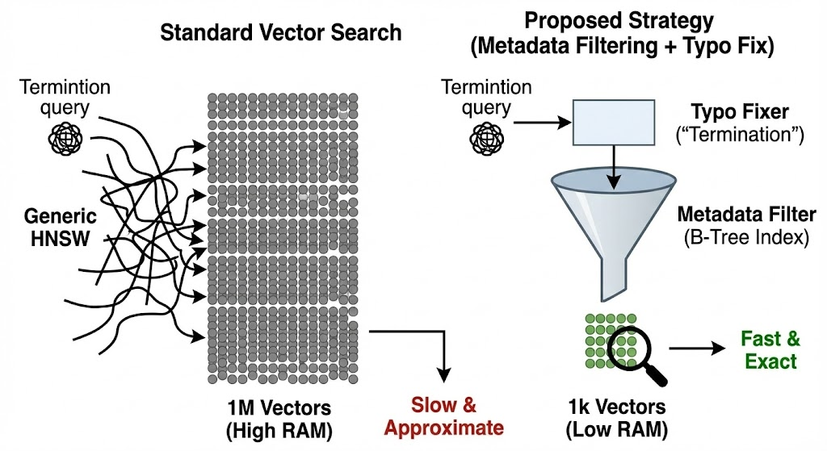
Feature | Standard Approach (Generic HNSW) | Proposed Strategy (Metadata Filtering + Typo Fix)
Search Scope | Scans the entire database (1M+ chunks) every time. | Scans only the relevant Act/Section (e.g., ~1k chunks).
RAM Requirement | High. Must keep the huge HNSW index in memory to be fast. | Low. Only loads small partition subsets into memory.
Accuracy (Recall) | Approximate. HNSW sacrifices some accuracy for speed; might miss niche legal clauses. | Exact. Uses Brute Force on the small subset, guaranteeing the mathematically best match.
Handling Typo Noise | Poor. "Termintion" vector is different from "Termination" vector; likely returns garbage. | Excellent. Python layer fixes "Termintion" $\rightarrow$ "Termination" before vectorization.
Hallucination Risk | High. Might retrieve a Companies Act clause for an Employment question if vectors are similar. | Zero. The metadata filter physically blocks irrelevant Acts from being searched.
Scalability | Costs grow linearly with data volume (more data = bigger server needed). | Costs remain flat; searching a specific Act takes the same time regardless of how many other Acts exist.

